Grace Long Torales

PENeo08

1. MERGE (gcis12314:Section {sectionID: "GCIS12314", title: "Python Programming", creditHours: 4, room: "GOL-2510"})

MERGE (iste43401:Section {sectionID: "ISTE43401", title: "Data Warehousing", creditHours: 4, room: "GOL-2620"})

MERGE (ava:Student {uid: "123456789", firstName: "Ava", lastName: "Wellings", year: 1})

MERGE (john:Student {uid: "234567890", firstName: "John", lastName: "Malincheck", year: 4})

MERGE (bianca:Student {uid: "345678901", firstName: "Bianca", lastName: "Summers", year: 3})

MERGE (ava)-[:ENROLLED_IN]->(gcis12314)

MERGE (john)-[:ENROLLED_IN]->(gcis12314)

MERGE (john)-[:ENROLLED_IN]->(iste43401)

MERGE (bianca)-[:ENROLLED_IN]->(iste43401)

1. MATCH (n)

OPTIONAL MATCH (n)-[r]-(m)

RETURN COLLECT(DISTINCT n) AS nodes, COLLECT(DISTINCT r) AS relationships

Results:

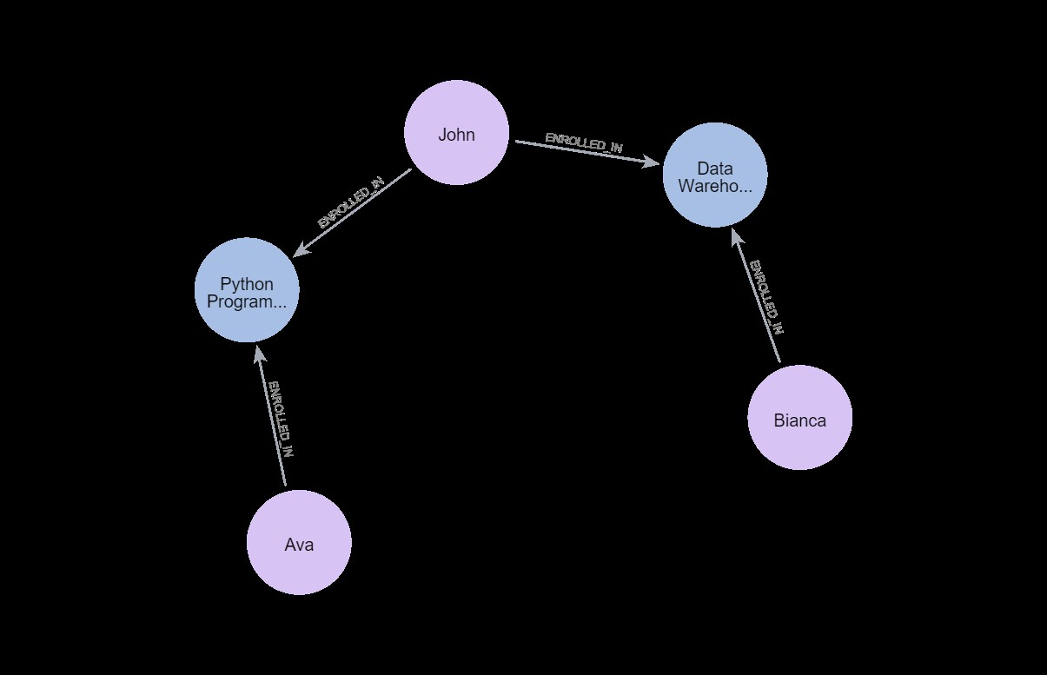

1. MATCH (p)<-[:ENROLLED_IN]-(c)

RETURN p.title AS sectionName, c.firstName + " " + c.lastName AS fullName

Results:

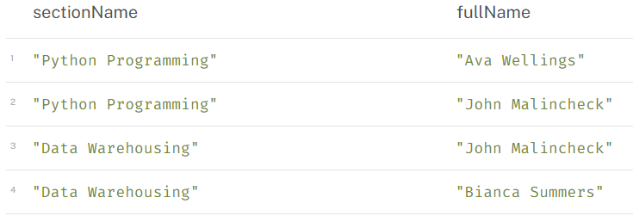

1. MATCH (p:Student)-[]->(c)

WITH p.firstName + " " + p.lastName AS fullName, SUM(c.creditHours) AS totalHours

RETURN AVG(totalHours)  
Results:

